Overall Winner
Bernard Mpofu of the NewsHawks
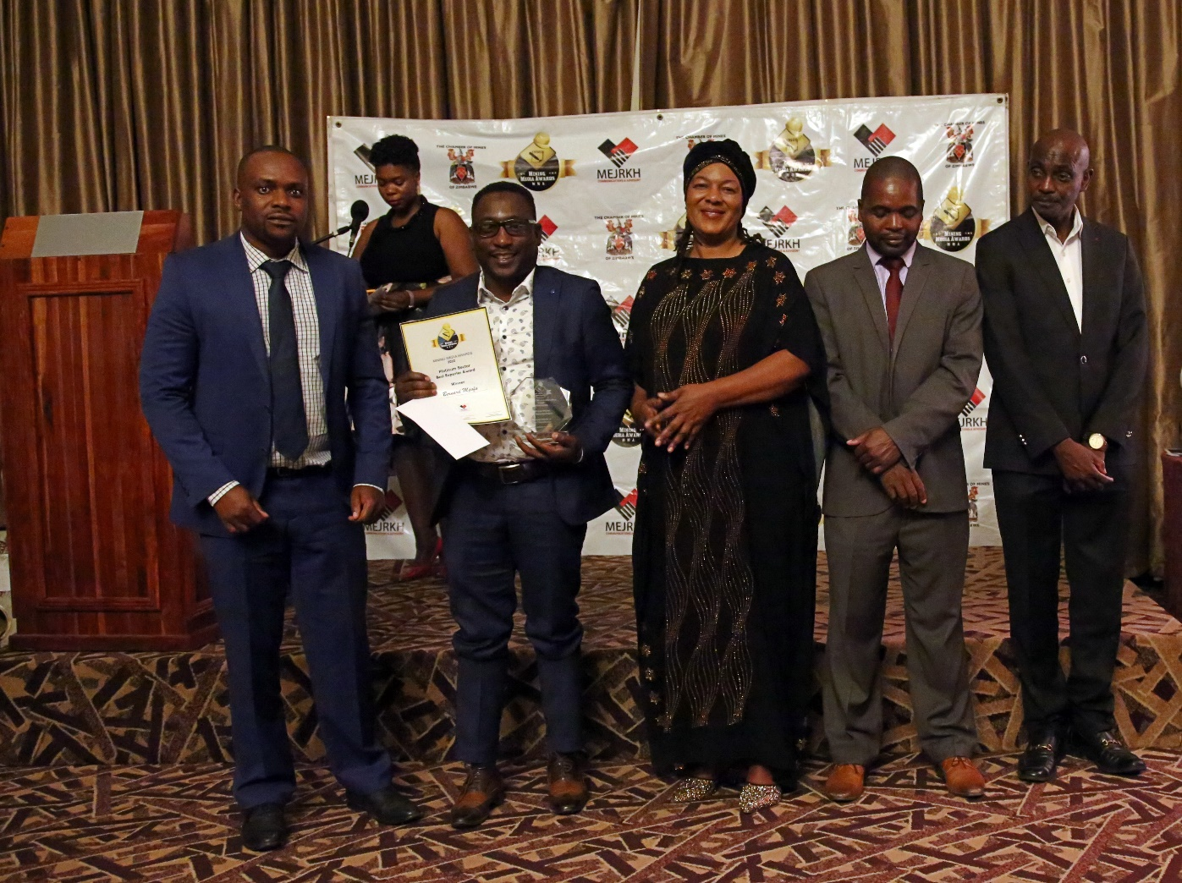

Gold Sector Best Reporter Award
Winner : Mary Mundeya of the NewsHawks
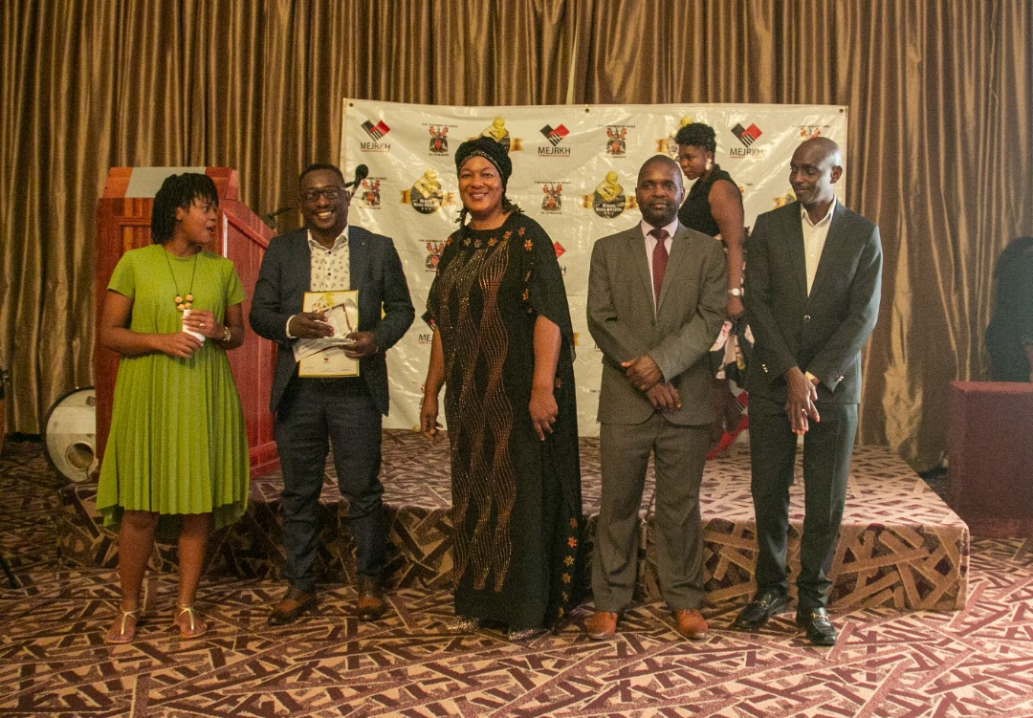
Headline : Politically linked gold dealers mint money through govt incentives
Link : https://thenewshawks.com/politically-linked-gold-dealers-mint-money-through-govt- incentives/

Runner up: Stephen Chadenga a freelance journalist
Headline : Gold miner degrades Shurugwi’s scenic Boterekwa
Link : https://thenewshawks.com/gold-miner-degrades-shurugwis-scenic-boterekwa/

Small Scale and Artisanal Miners Best Reporter Award
Winner : Gibson Mhaka of the Chronicle
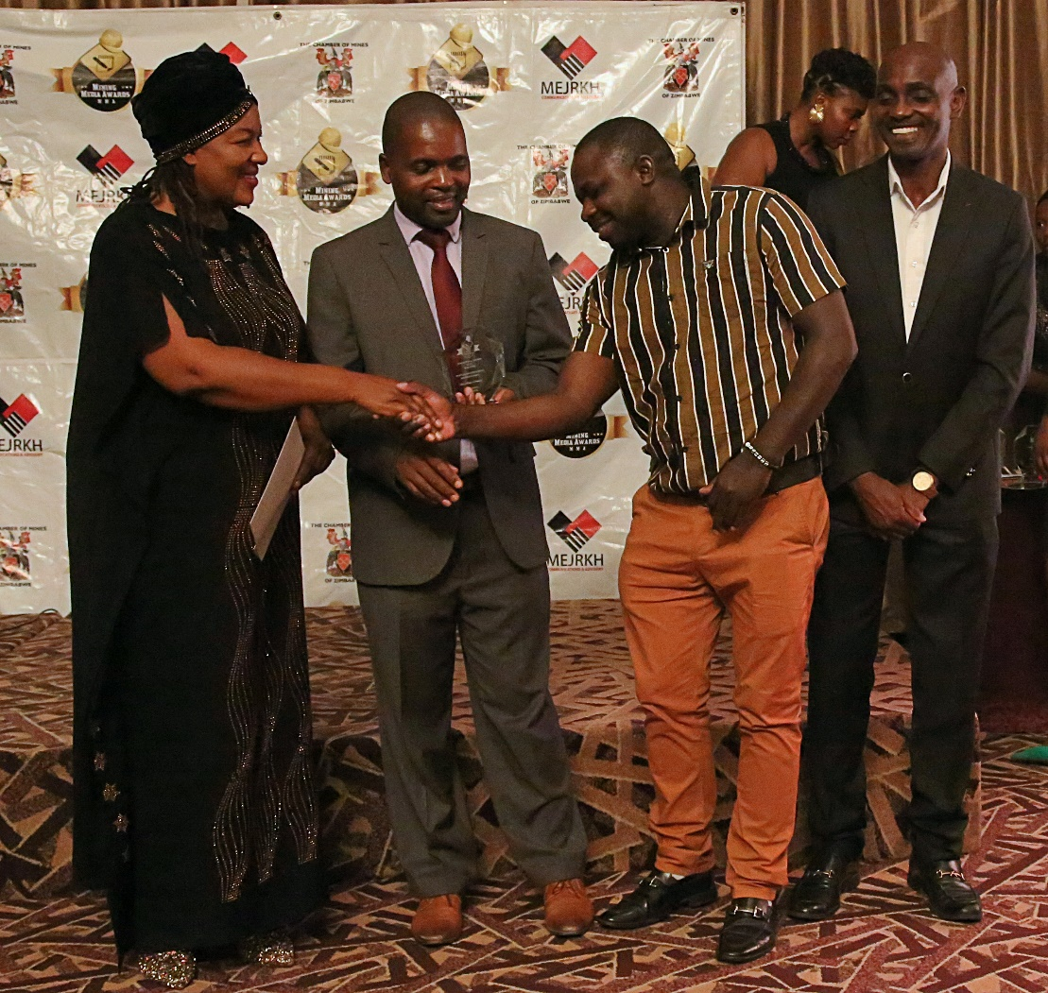
Headline : Investment in health and safety a neglected issue in the ASM sector
Link : Investment in health and safety a neglected issue in the ASM sector | The Chronicle

Runner up:Patrick Chitumba of the Chronicle
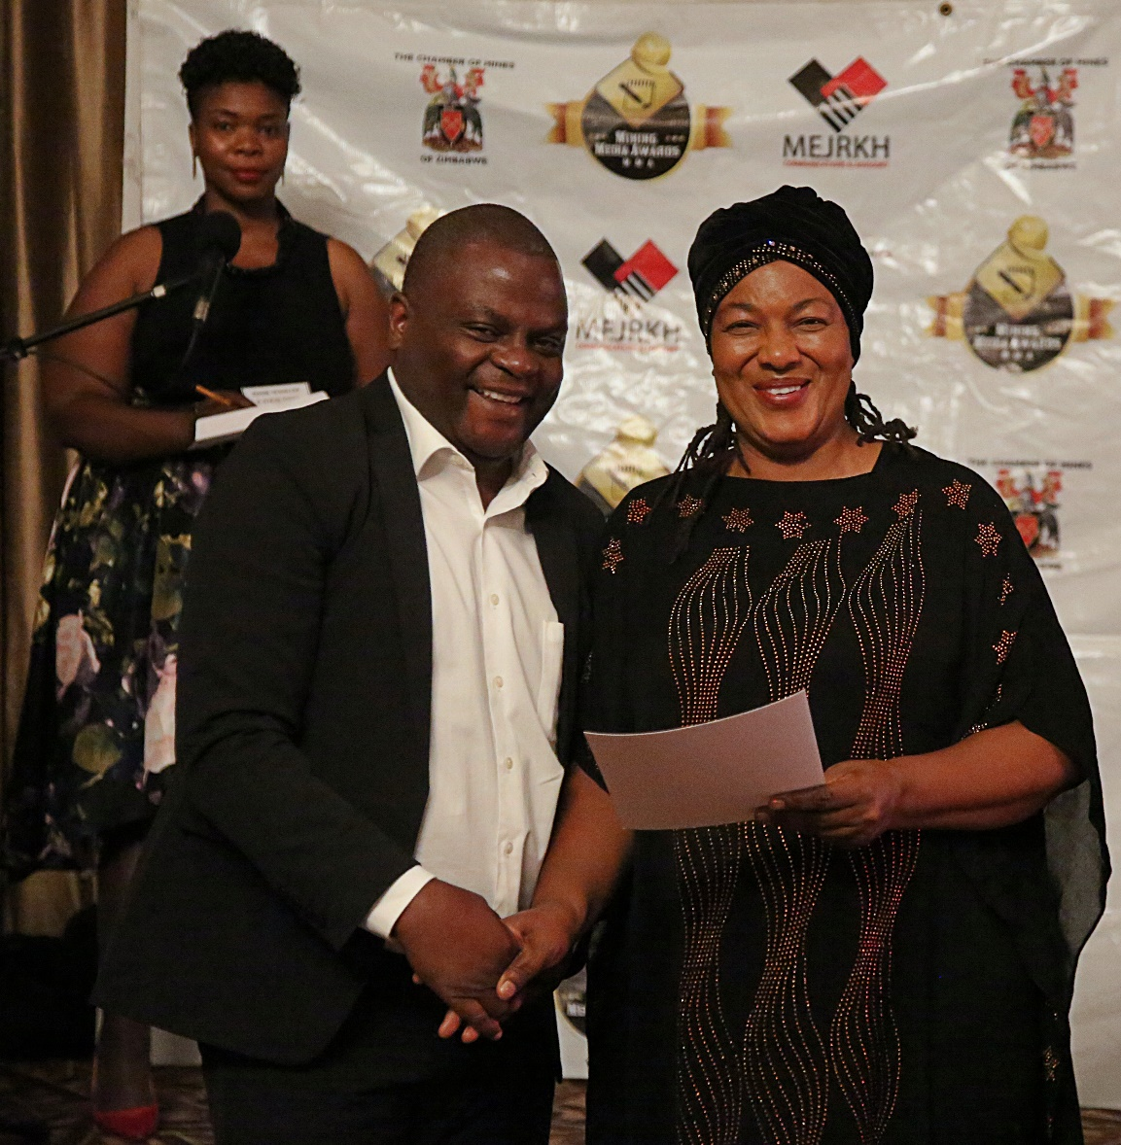
Headline : Poverty, artisanal mining and the surge in teenage pregnancies
Link : https://www.chronicle.co.zw/poverty-artisanal-mining-and-the-surge-in-teenage-pregnancies/

Platinum Sector Best Reporter Award
Winner :Bernard Mpofu of the NewsHawks
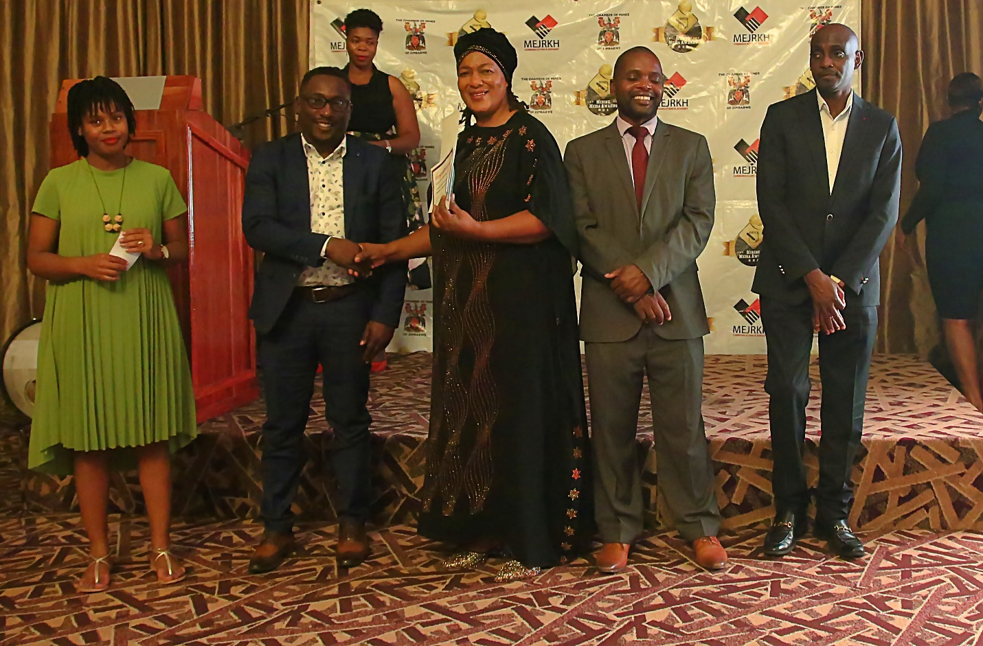

Headline : Zim’s US$3bn platinum deal all but collapses in a shambles
Link : https://thenewshawks.com/zims-us3bn-platinum-deal-all-but-collapses-in-a-shambles/

Runner up :Adelaide Moyo of the Financial Gazette
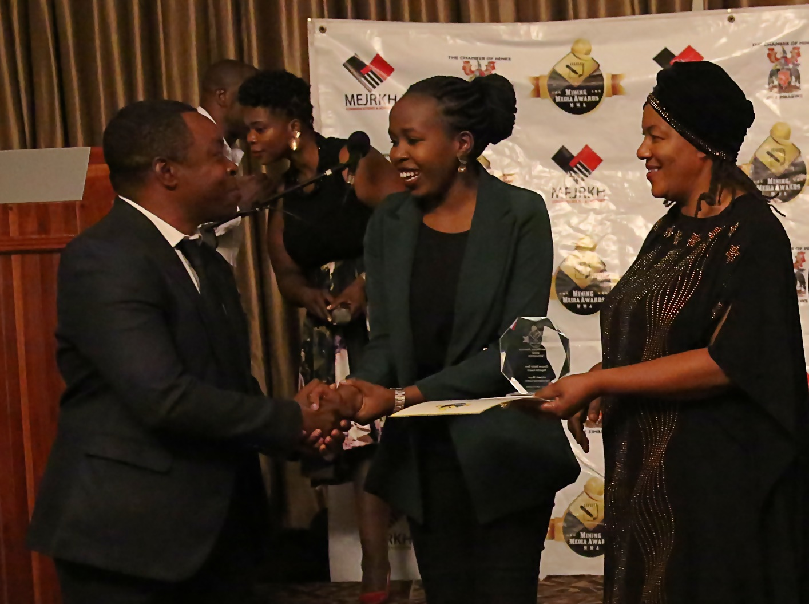
Headline : Zim platinum production up 6pct
Link : You searched for Zim platinum production up 6pct - The Financial Gazette (fingaz.co.zw)

Corporate Social Responsibility and Sustainability Award
Winner :Judith Phiri of the Sundaynews
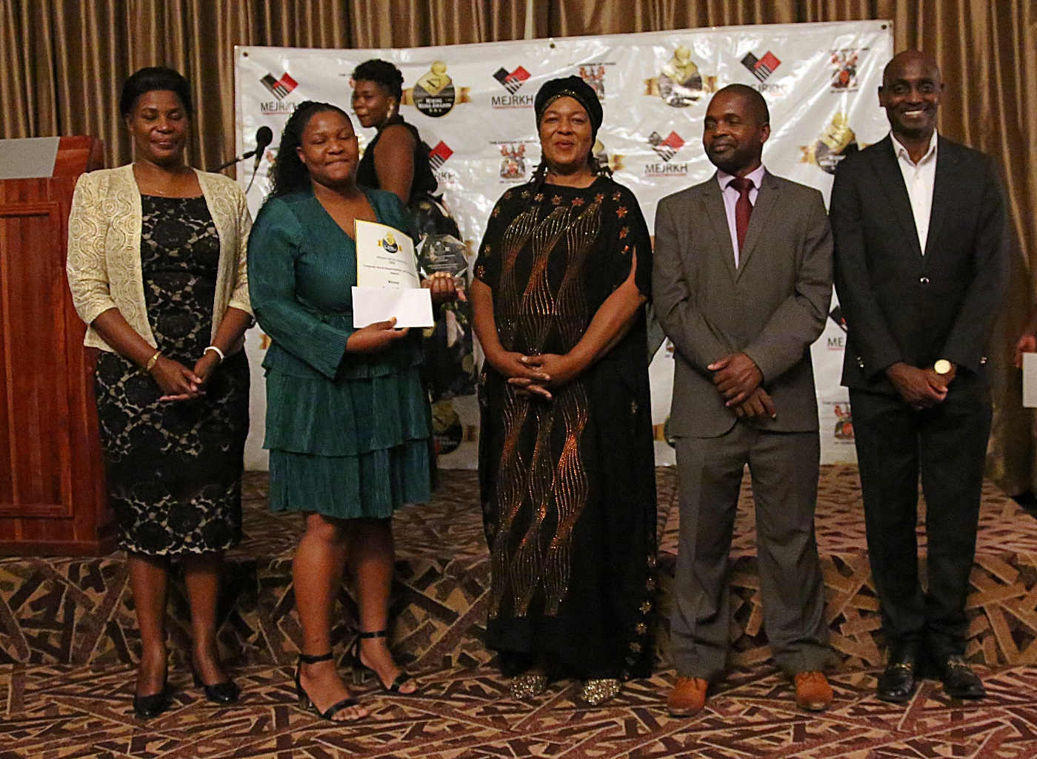
Headline : Community development a priority for Bikita Minerals new investors
Link : https://www.sundaynews.co.zw/community-development-a-priority-for-bikita-minerals-new-investors/

Runner up: Patrick Chitumba of the Chronicle
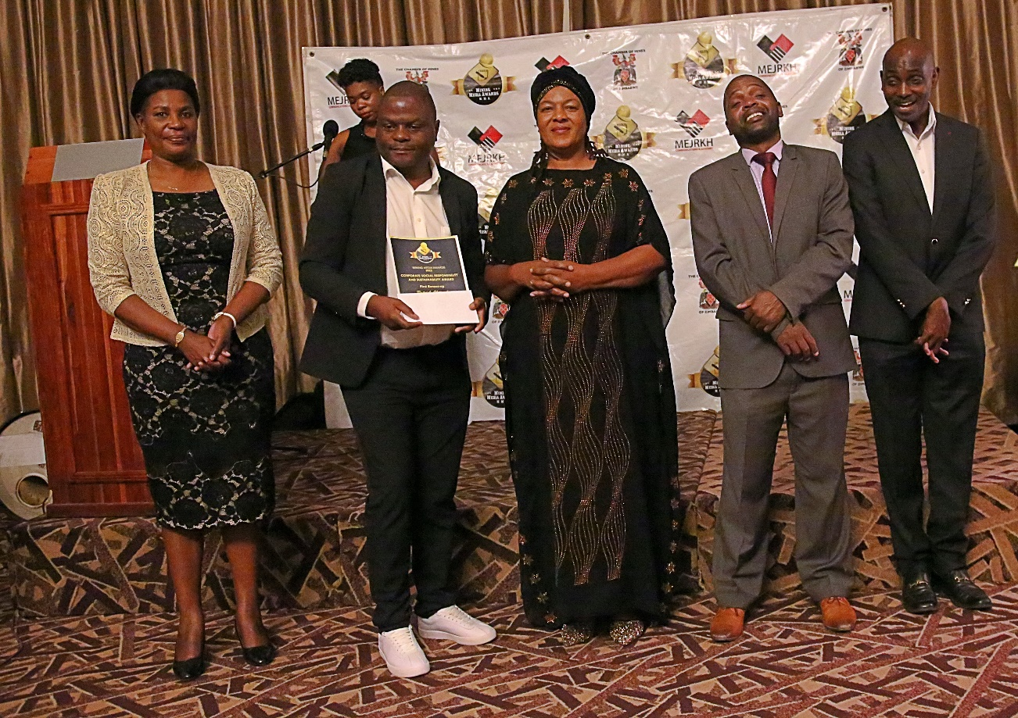
Headline : Shurugwi farmers secure foreign markets
Link : https://www.chronicle.co.zw/shurugwi-farmers-secure-foreign-markets/

Coal and Gas Best Reporter Award
Winner :Kudzanai Gerede of 263 Chat
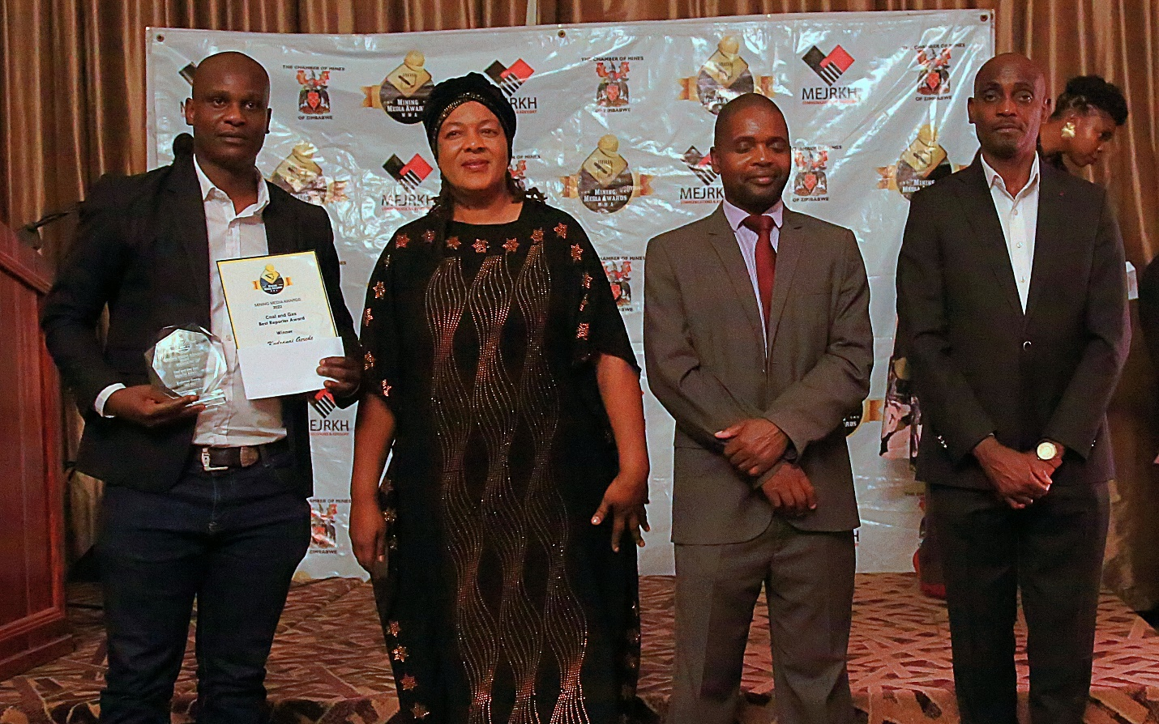
Headline : Will Hwange become Zim’s next ghost town? as world moves away from fossil fuels
Link : https://www.263chat.com/will-hwange-become-zims-next-ghost-town-as-world-moves-away-from-fossil-fuels/

Runner up:Gibson Mhaka of the Chronicle
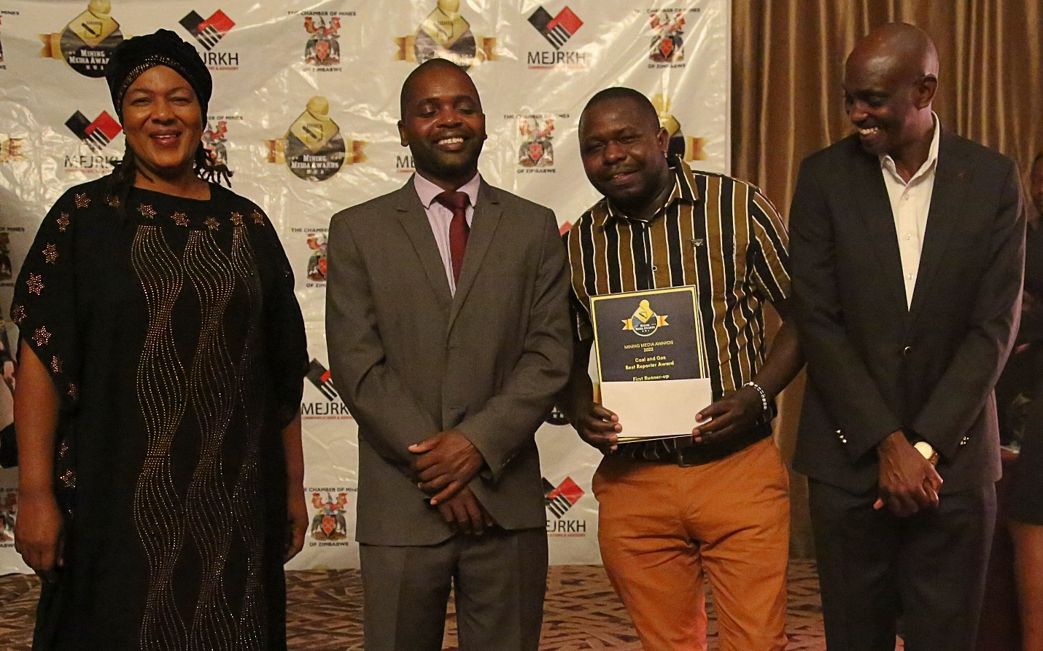
Headline : Turning an environmental problem into a solution
Link : Turning an environmental problem into a solution | The Chronicle

Diamond Sector Best Reporter Award
Winner :Bernard Mpofu of the NewsHawks
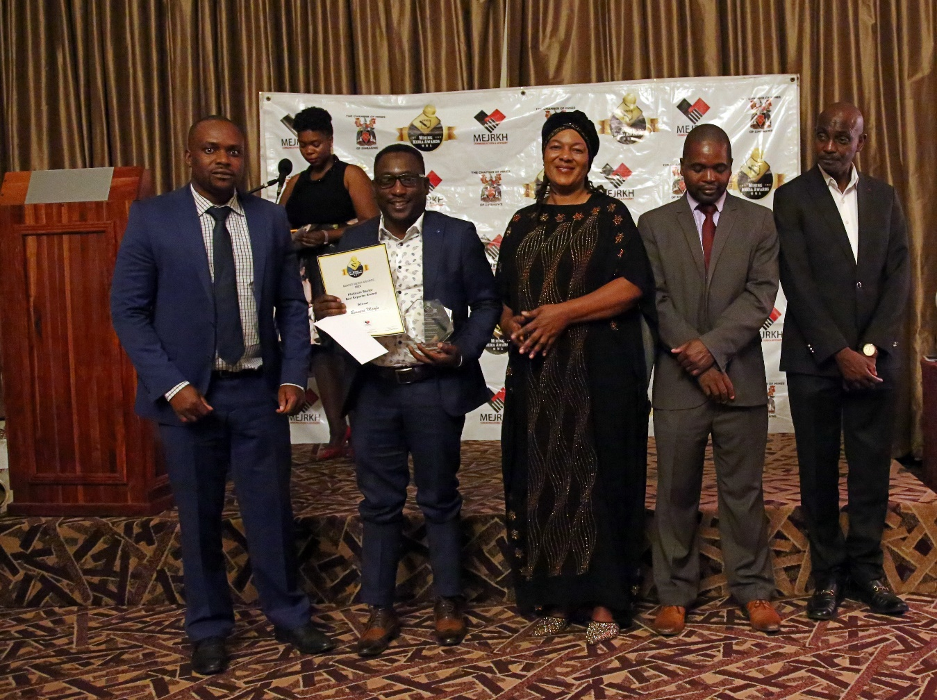
Headline : Scandalous plundering of precious minerals continues
Link : https://thenewshawks.com/scandalous-mismanagement-of-minerals-continues/

Runner up:Nathan Guma of the NewsHawks
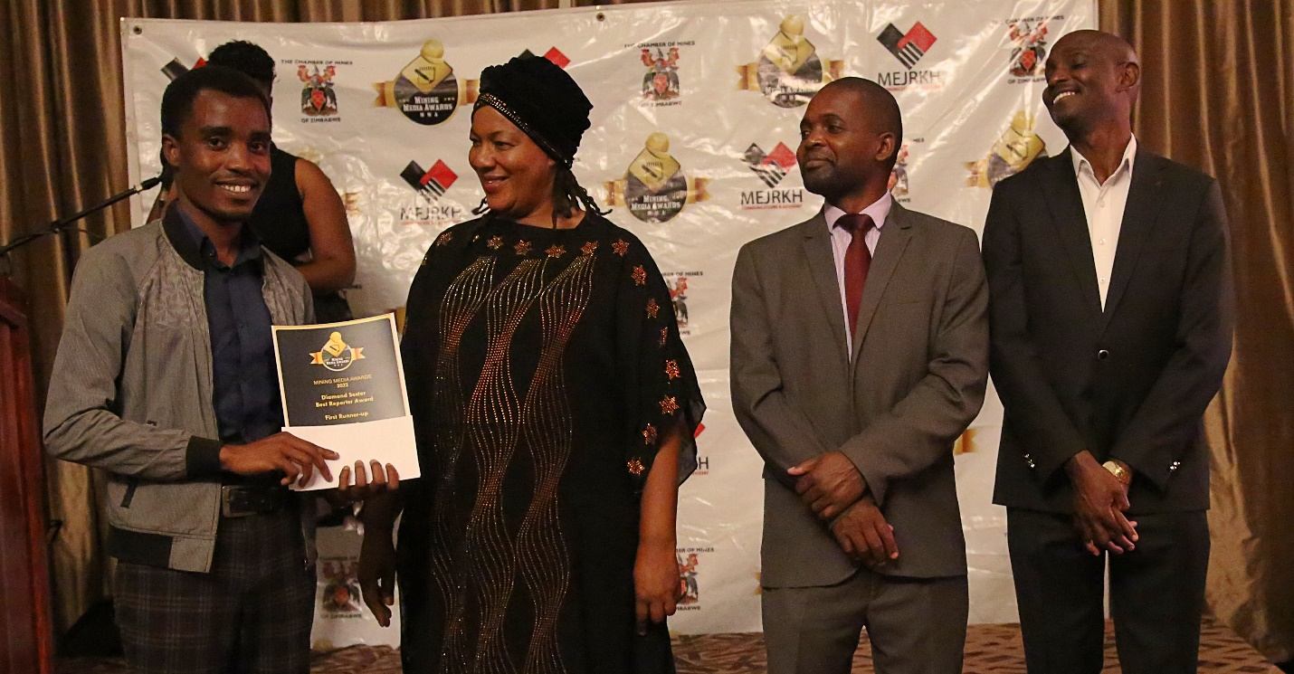
Headline : Illicit trade in minerals at the heart of resource curse
Link : https://thenewshawks.com/illicit-trade-in-minerals-at-the-heart-of-resource-curse/

Chrome sector Best Reporter Award
Winner :Adelaide Moyo of the Financial Gazette
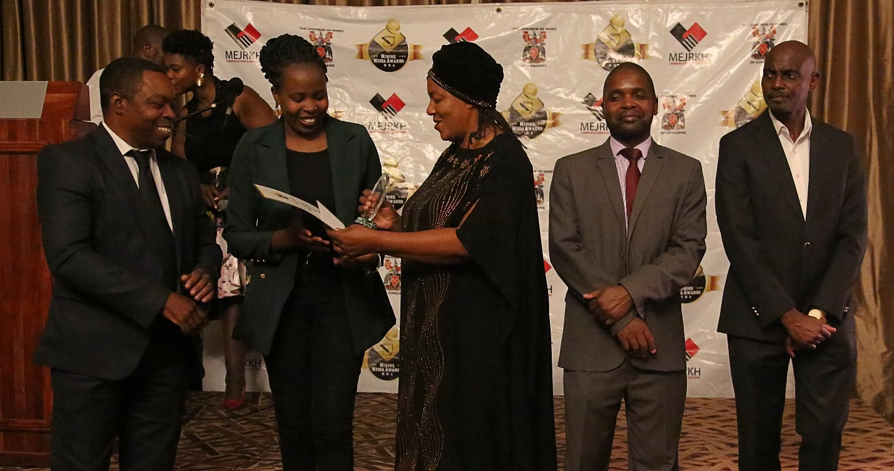
Headline : Chrome miners on rebound despite Covid
Link : You searched for Chrome miners on rebound despite Covid - The Financial Gazette (fingaz.co.zw)

Runner up :Bernard Mpofu of the NewsHawks
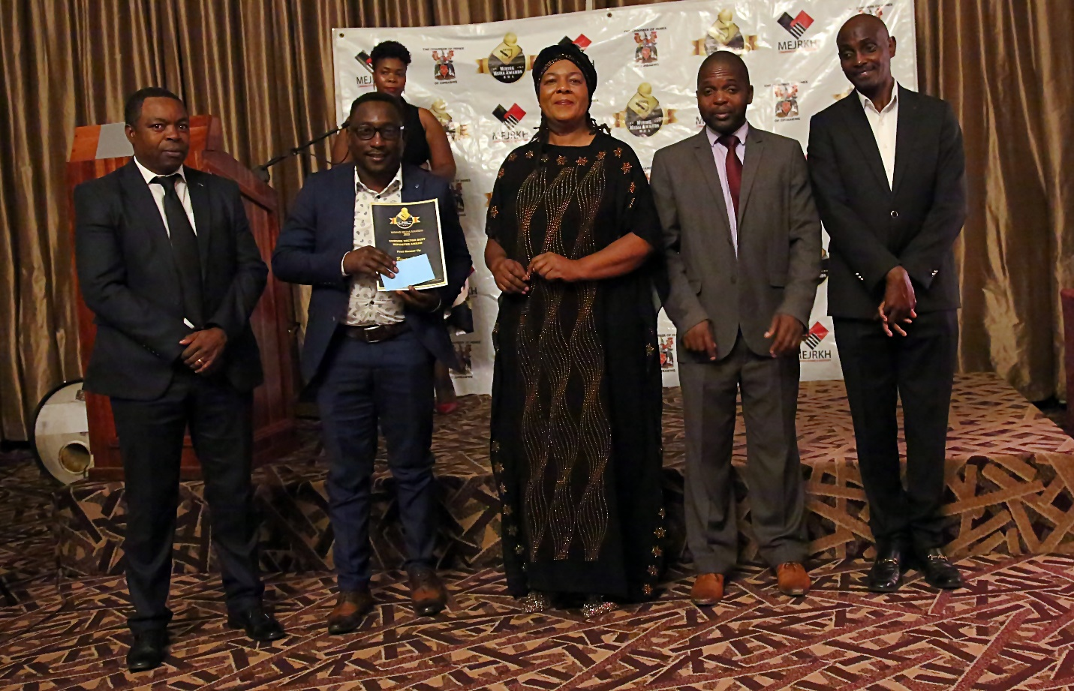
Headline : Chrome miners get export reprieve
Link : https://thenewshawks.com/chrome-miners-get-export-reprieve/

Lithium Sector Best Reporter Award
Winner :Michelle Chifamba a freelance journalist
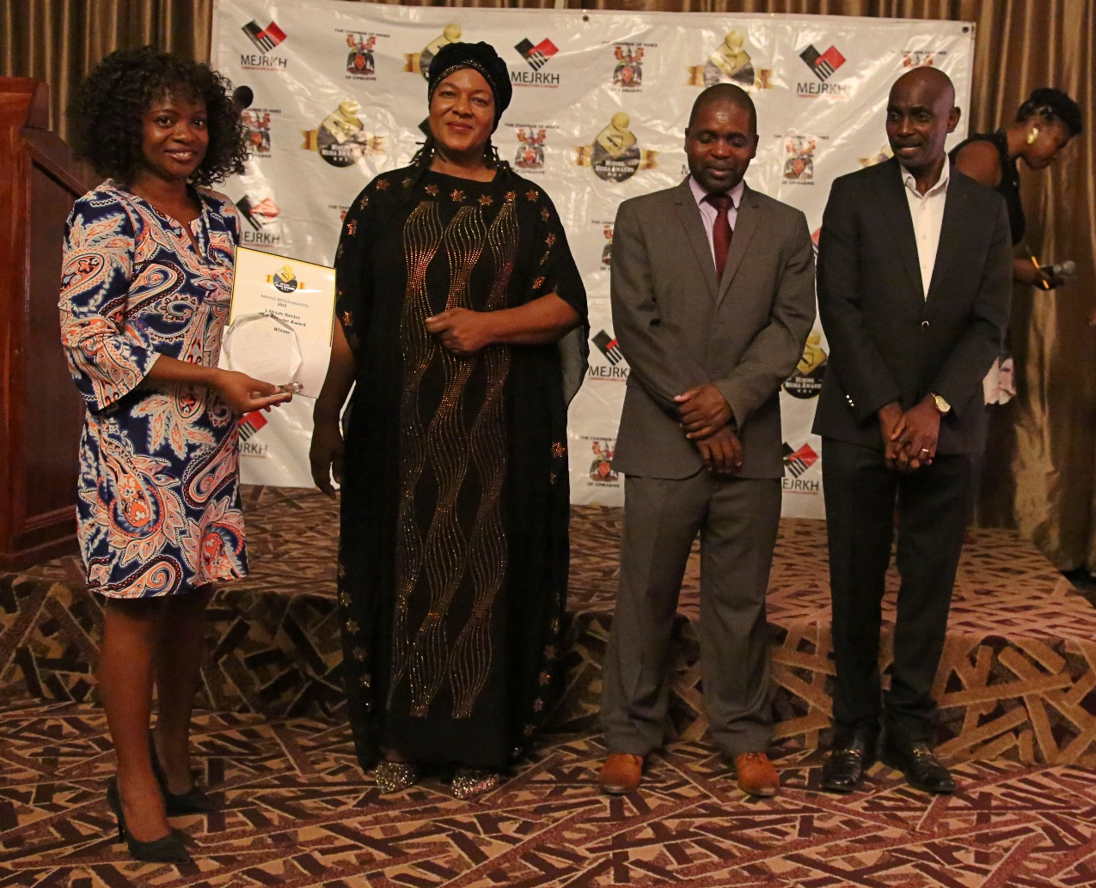

Headline : Zimbabwe looks to lithium to power electric car revolution and its economy
Link : https://www.theafricareport.com/149489/zimbabwe-looks-to-lithium-to-power-electric-car-revolution-and-its-economy/

Runner up: Owen Mandovha of ZBC
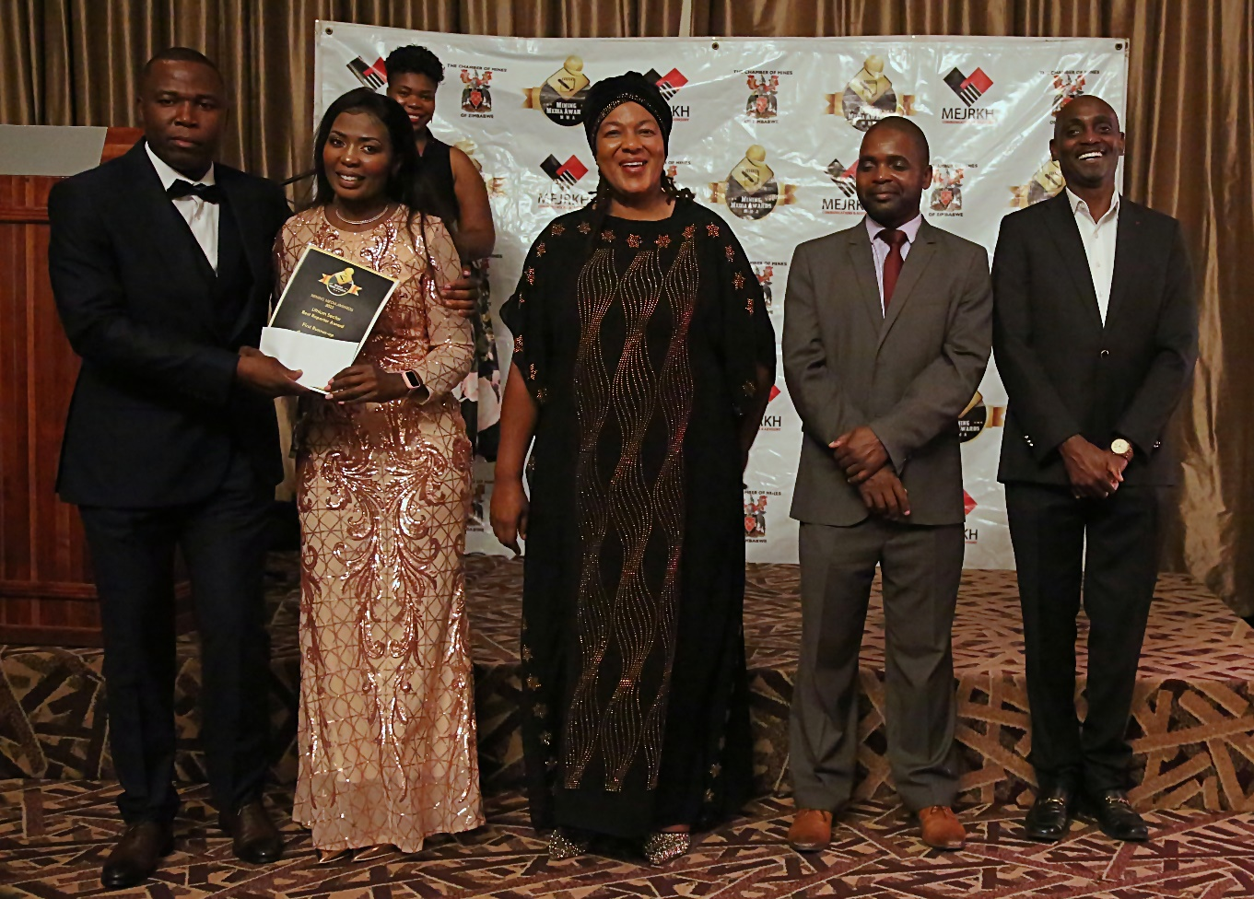
Headline :
Link :

